# Lab 2: Running Your Project

## Objectives

*  Run the project
*  Make a change and see the app update
*  Stop the project

## Steps

### Run the project

1. **Run** one of the following commands:

npm start

1. After the application builds, it will **automatically** **open** your Chrome **browser** to [http://localhost:3000](http://localhost:3000/" \t "https://handsonreact.com/docs/labs/js/_blank).
2. **Verify** the **React logo** is displayed in the browser.

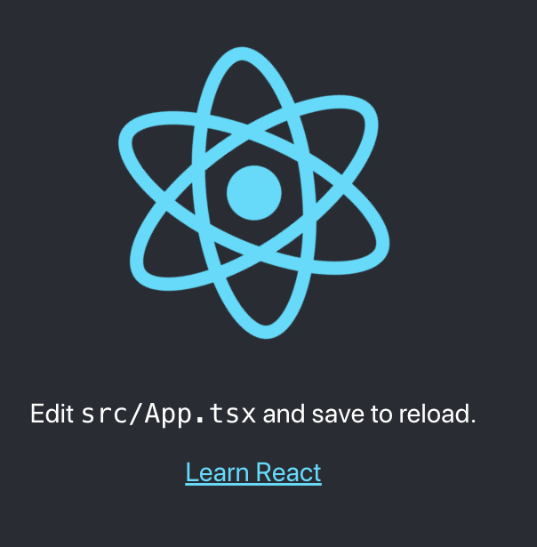

### Make a change and see the app update

1. **Add** some additional text (exclamation points) in the render method of the App component as shown below.

#### src\App.js

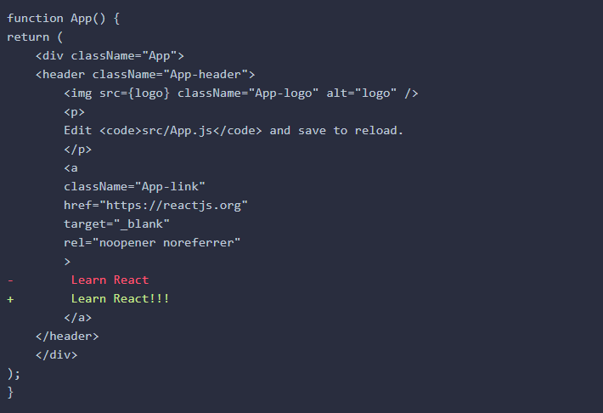

1. **Save** your changes to the file.

In the VS Code menu bar you can turn on File > Autosave and this is recommended for the course.

1. **Verify** the additional text is displayed in your browser.

The page will automatically reload if you make changes to the code. The file saves then the code compiles then the browser refreshes.

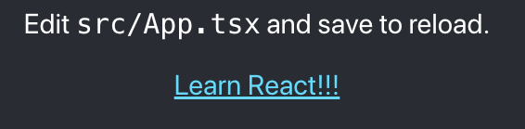

### Stop the Project

1. **Focus** your **cursor** in the command prompt (Windows) or terminal (Mac).
2. **Type** Ctrl + C.

On Windows you will be prompted with Are you sure you want to... (Y/N)...type y.

1. Use what you learned earlier in the lab to **restart** the application.

### ✔ You have completed Lab 2